SPITCHICKEN

Theme: | Comics/CARTOON
School: | secondary
Age group: | 13 and up
Duration: | Startup: 1 hour
Participants: | class
Class setting (tables and chairs): | Preferably (though not necessarily) use an ‘arts’ room if there is one available.
Relevant background information : | The cartoon can be either handmade or via photos taken from the internet. Students are free to use empty cartoon templates or make their own version. The cartoon must, however, contain both visual as well as textual elements. Students are not to be judged on their artistic skills as much as on their narrative endeavor. The teacher can use the outcome as a means to ‘map’ students’ perspective on the theme. The fact that the themes are woven into a fairy tale provides students with the opportunity to be both creative and ‘free’ to express their ideas. Most importantly it will force students to think how they think what homosexuality looks like. This in turn will provide plenty of data for various forms of follow-up lessons.
Teaching strategy: | (Running through this assignment with an arts teacher, artist, cartoonist etc. if you are a professional without any artistic affinity is advisable. It could also be integrated into an arts class or project).  PHASE I  Let students pick a fairy tale. Then have them choose a scene or part of the story that contains some element of travel. Next, have them support (either verbally or written down) why and how they will weave in the themes into the scene.  The teacher needs to feel confident he/she can assist this process of decision making. Why not let the teacher make a version of his/here own…  PHASE II  Make the cartoon.  The teacher should be mindful not to interfere or condemn (within reason) the choices of the students (unless there is a breach of ethical, moral or judicial boundaries). Instead, the teacher should inquire and encourage the students to think and reason about why they end up making the choices they make.  PHASE III  Present and discuss the outcome.  Students are encouraged to support the artistic choices they made. Not regarding the quality of the outcome but more of why they chose a certain style.  Inspiration  - The teacher can provide visual examples of fairy-tales where a journey is pictured. A quick google search provides plenty of examples. Showing part of cartoon (via youtube) is also a possibility to (a hero’s journey for example is a widespread theme in fairy-tales so there are plenty of examples to find and show).  - Collecting some different examples of cartoons or allow students to bring their own could also help stimulate to maybe even emulate a certain style or look.

1. What you will need

- Have plenty of work space and artistic material available (pens, crayons, paint, paper etc. as well as old magazines, newspapers etc. they can cut up)
- Access to the internet to find a fairy tale and or, books containing fairy tales

2. Content/theme:

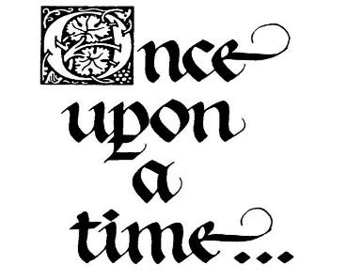
Students make their own cartoon based on an existing fairy tale which they are free to choose. However, the fairy tale must be altered to contain the theme of homosexuality or diversity ánd needs to have an element of travel (like part of a journey for instance). Students are free to pick a specific scene or part of the story. Preferably the scene contains some form of a dramatic conflict. It must be short enough to fit into one page.
The cartoon can be either handmade or via photos taken from the internet. Students are free to use empty cartoon templates or make their own version. The cartoon must, however, contain both visual as well as textual elements. Students are not to be judged on their artistic skills as much as on their narrative endeavor. The teacher can use the outcome as a means to ‘map’ students’ perspective on the theme. The fact that the themes are woven into a fairy tale provides students with the opportunity to be both creative and ‘free’ to express their ideas. Most importantly it will force students to think how they think what homosexuality looks like. This in turn will provide plenty of data for various forms of follow-up lessons.

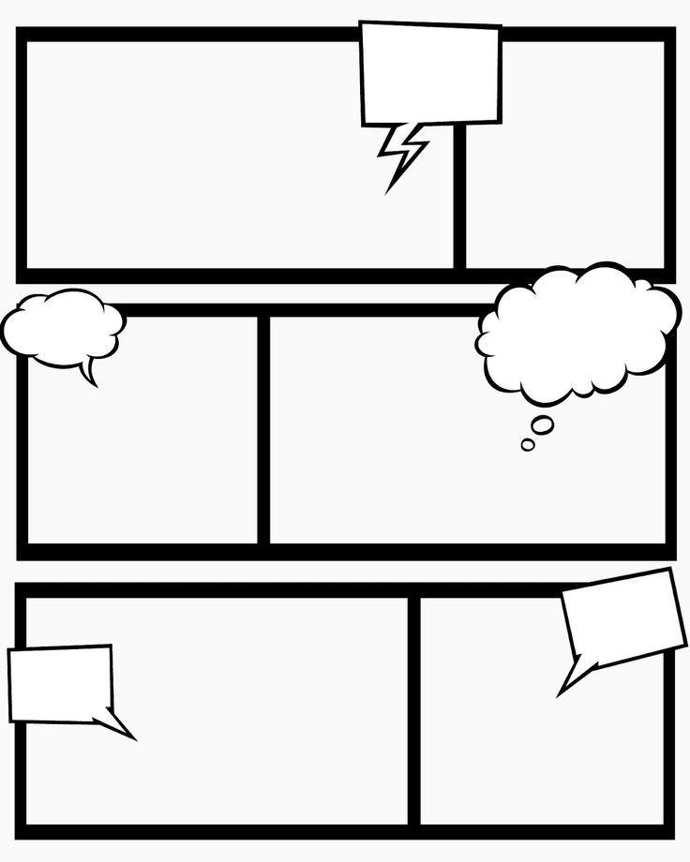

Example of an empty comic template. Google has many other examples available, if you want to get creative.

